**Ref. Use Template from the Existing software..**

**Also include (last updated on ___ )**

**(Header (same pattern), but Form number, Revision, date choosable by client MR)**

**Footer – Prepared by MR**

**Include “Level”**

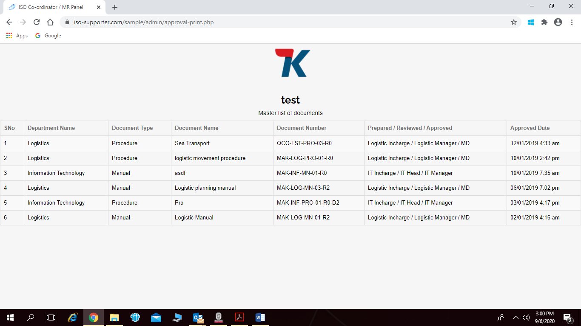

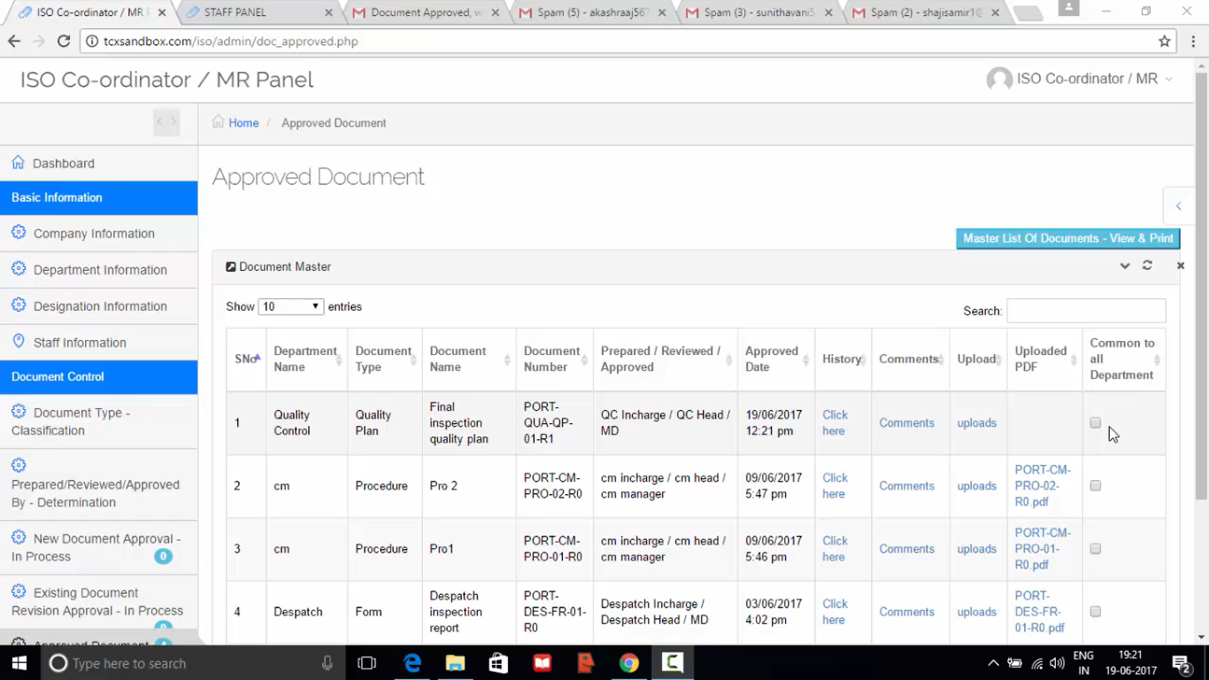

UPDATED ON:___